Experiment 7

**Name** : Mohammad Wasi

**SAP ID** : 500110709

**Batch** : AIML B8

Aim: To implement input validation using AngularJS..**.**

**Objective :**

1. Implement input validation using AngularJS.
2. Develop a cost calculator application.
3. Build a simple search filter functionality.

4. Utilize AngularJS Tables for displaying data.

Theory :

AngularJS is a JavaScript framework for building dynamic web applications. It simplifies development by providing a structured framework for client-side MVC architecture. With its two-way data binding and dependency injection, AngularJS enhances the functionality and responsiveness of web applications.

**Code**

**-- Question 1: Code to change the background of the textbox based on the color mentioned by the user.**

<!DOCTYPE html>

<html>

<head>

<title>AngularJS Input Validation</title>

<script src="https://ajax.googleapis.com/ajax/libs/angularjs/1.8.2/angular.min.js"></script>

<script src="app.js"></script>

<link rel="stylesheet" type="text/css" href="styles.css">

</head>

<body ng-app="myApp">

<div ng-controller="MainController">

<input type="text" ng-model="color" ng-style="{'background-color': color}" placeholder="Enter color name">

</div>

</body>

</html>

// app.js

var app = angular.module('myApp', []);

app.controller('MainController', function($scope) {

// Controller logic here

});

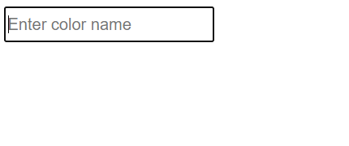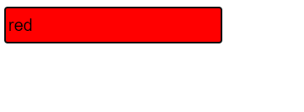

**-- Question 2: Code to create a cost calculator.**

<!DOCTYPE html>

<html>

<head>

<title>Cost Calculator</title>

<script src="https://ajax.googleapis.com/ajax/libs/angularjs/1.8.2/angular.min.js"></script>

<script src="app.js"></script>

<link rel="stylesheet" type="text/css" href="styles.css">

</head>

<body ng-app="myApp">

<div ng-controller="MainController">

<input type="number" ng-model="quantity" placeholder="Enter quantity"><br>

<input type="number" ng-model="price" placeholder="Enter price per item"><br>

Total cost: {{quantity * price | currency}}

</div>

</body>

</html>

// app.js

var app = angular.module('myApp', []);

app.controller('MainController', function($scope) {

});

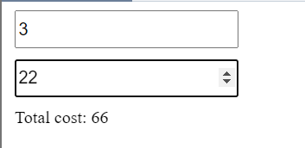

**-- Question 3: Code to build a simple search filter functionality:**

<!DOCTYPE html>

<html>

<head>

<title>Search Filter</title>

<script src="https://ajax.googleapis.com/ajax/libs/angularjs/1.8.2/angular.min.js"></script>

<script src="wasi.js"></script>

<link rel="stylesheet" type="text/css" href="wasi.css">

</head>

<body ng-app="wasiApp">

<div ng-controller="WasiController">

<input type="text" ng-model="wasiSearch" placeholder="Search">

<ul>

<li ng-repeat="item in wasiItems | filter:wasiSearch">{{item}}</li>

</ul>

</div>

</body>

</html>

// wasi.js

var wasiApp = angular.module('wasiApp', []);

wasiApp.controller('WasiController', function($scope) {

$scope.wasiItems = [

'Macbook Pro',

'Macbook Air',

'iMac',

'iPhone',

'iPad',

'Apple Watch',

'AirPods'

];

});

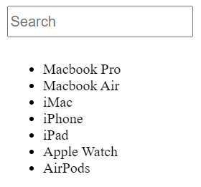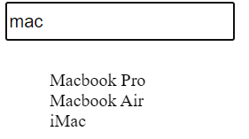

**-- Question 4: Code to use AngularJS Tables:**

<!DOCTYPE html>

<html>

<head>

<title>AngularJS Tables</title>

<script src="https://ajax.googleapis.com/ajax/libs/angularjs/1.8.2/angular.min.js"></script>

<script src="wasi.js"></script>

<link rel="stylesheet" type="text/css" href="wasi.css">

</head>

<body ng-app="wasiApp">

<div ng-controller="WasiController">

<table>

<thead>

<tr>

<th>ID</th>

<th>Name</th>

</tr>

</thead>

<tbody>

<tr ng-repeat="item in wasiItems">

<td>{{item.id}}</td>

<td>{{item.name}}</td>

</tr>

</tbody>

</table>

</div>

</body>

</html>

// wasi.js

var wasiApp = angular.module('wasiApp', []);

wasiApp.controller('WasiController', function($scope) {

$scope.wasiItems = [

'Macbook Pro',

'Macbook Air',

'iMac',

'iPhone',

'iPad',

'Apple Watch',

'AirPods'

];

});